- Create an android application to demonstrate Quiz Application.
Design:

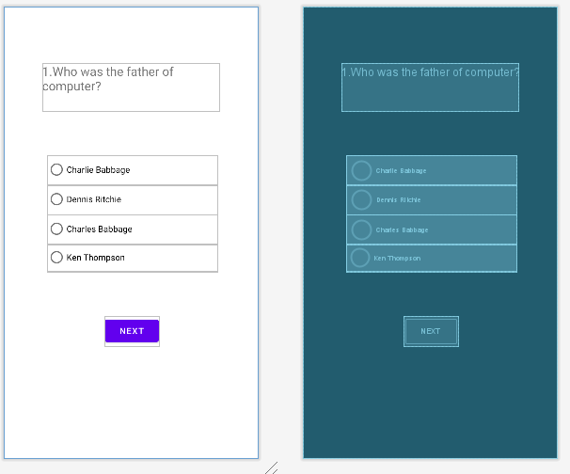
Xml Code:
<?xml version="1.0"encoding="utf-8"?>
<androidx.constraintlayout.widget.ConstraintLayout xmlns:android="http://schemas.android.com/apk/res/android"
xmlns:app="http://schemas.android.com/apk/res-auto"
xmlns:tools="http://schemas.android.com/tools"
android:layout_width="match_parent"
android:layout_height="match_parent"
tools:context=".MainActivity">
<TextView
android:id="@+id/txt1"
android:layout_width="286dp"
android:layout_height="78dp"
android:layout_marginStart="69dp"
android:layout_marginTop="91dp"
android:layout_marginEnd="101dp"
android:layout_marginBottom="581dp"
android:text="1.Who was the father of computer?"
android:textSize="20sp"
app:layout_constraintBottom_toBottomOf="parent"
app:layout_constraintEnd_toEndOf="parent"
app:layout_constraintHorizontal_bias="0.155"
app:layout_constraintStart_toStartOf="parent"
app:layout_constraintTop_toTopOf="parent"
app:layout_constraintVertical_bias="0.0"/>
<RadioGroup
android:id="@+id/radioGroup"
android:layout_width="275dp"
android:layout_height="188dp"
android:layout_marginStart="70dp"
android:layout_marginTop="65dp"
android:layout_marginEnd="67dp"
android:layout_marginBottom="298dp"
app:layout_constraintBottom_toBottomOf="parent"
app:layout_constraintEnd_toEndOf="parent"
app:layout_constraintStart_toStartOf="parent"
app:layout_constraintTop_toBottomOf="@+id/txt1">
<RadioButton
android:id="@+id/rb1"
android:layout_width="match_parent"
android:layout_height="wrap_content"
android:text="Charlie Babbage"/>
<RadioButton
android:id="@+id/rb2"
android:layout_width="match_parent"
android:layout_height="wrap_content"
android:text="Dennis Ritchie"/>
<RadioButton
android:id="@+id/rb3"
android:layout_width="match_parent"
android:layout_height="wrap_content"
android:text="Charles Babbage"/>
<RadioButton
android:id="@+id/rb4"
android:layout_width="match_parent"
android:layout_height="wrap_content"
android:text="Ken Thompson"/>
</RadioGroup>
<Button
android:id="@+id/bt1"
android:layout_width="wrap_content"
android:layout_height="wrap_content"
android:layout_marginStart="160dp"
android:layout_marginTop="73dp"
android:layout_marginEnd="157dp"
android:layout_marginBottom="182dp"
android:text="next"
app:layout_constraintBottom_toBottomOf="parent"
app:layout_constraintEnd_toEndOf="parent"
app:layout_constraintStart_toStartOf="parent"
app:layout_constraintTop_toBottomOf="@+id/radioGroup"/>
</androidx.constraintlayout.widget.ConstraintLayout>

Xml fifthActivity code:
<?xml version="1.0" encoding="utf-8"?>
<androidx.constraintlayout.widget.ConstraintLayout xmlns:android="http://schemas.android.com/apk/res/android"
xmlns:app="http://schemas.android.com/apk/res-auto"
xmlns:tools="http://schemas.android.com/tools"
android:layout_width="match_parent"
android:layout_height="match_parent">
<TextView
android:id="@+id/textView"
android:layout_width="376dp"
android:layout_height="163dp"
android:layout_marginStart="35dp"
android:layout_marginEnd="51dp"
android:textSize="50dp"
app:layout_constraintBottom_toBottomOf="parent"
app:layout_constraintEnd_toEndOf="parent"
app:layout_constraintStart_toStartOf="parent"
app:layout_constraintTop_toTopOf="parent" />
</androidx.constraintlayout.widget.ConstraintLayout>

Manifest.xml:
<?xml version="1.0"encoding="utf-8"?>
<manifest xmlns:android="http://schemas.android.com/apk/res/android"
xmlns:tools="http://schemas.android.com/tools"
package="com.example.quize">
<application
android:allowBackup="true"
android:dataExtractionRules="@xml/data_extraction_rules"
android:fullBackupContent="@xml/backup_rules"
android:icon="@mipmap/ic_launcher"
android:label="@string/app_name"
android:roundIcon="@mipmap/ic_launcher_round"
android:supportsRtl="true"
android:theme="@style/Theme.Quize"
tools:targetApi="31">
<activity
android:name=".MainActivity"
android:exported="true">
<intent-filter>
<action android:name="android.intent.action.MAIN"/>
<category android:name="android.intent.category.LAUNCHER"/>
</intent-filter>
</activity>
<activity android:name=".second"/>
<activity android:name=".third"/>
<activity android:name=".four"/>
<activity android:name=".five"/>
</application>
</manifest>

MainActivity.java

package com.example.quize;
import androidx.appcompat.app.AppCompatActivity;
import android.content.Intent;
import android.os.Bundle;
import android.view.View;
import android.widget.Button;
import android.widget.RadioButton;
import android.widget.Toast;
import com.google.android.material.color.utilities.Score;
public class MainActivity extends AppCompatActivity {
int score=0;
Button btn1;
@Override
protected void onCreate(Bundle savedInstanceState) {
super.onCreate(savedInstanceState);
setContentView(R.layout.activity_main);
btn1=(Button) findViewById(R.id.bt1);
RadioButton rbtn3=(RadioButton) findViewById(R.id.rb3);
btn1.setOnClickListener(new View.OnClickListener() {
@Override
public void onClick(View view) {
if(rbtn3.isChecked())
{
score=score+1;
Toast.makeText(MainActivity.this, "Correct answer"+ score,Toast.LENGTH_SHORT).show();
}
else
{
Toast.makeText(MainActivity.this, "Wrong answer"+ score,Toast.LENGTH_SHORT).show();
}
Intent i=new Intent(MainActivity.this,second.class);
i.putExtra("totalscore",score);
startActivity(i);
}
});
}
}

secondActivity.java

package com.example.quize;
import android.content.Intent;
import android.os.Bundle;
import android.view.View;
import android.widget.Button;
import android.widget.RadioButton;
import android.widget.Toast;
public class second extends MainActivity{
int score=0;
@Override
protected void onCreate(Bundle savedInstanceState) {
super.onCreate(savedInstanceState);
setContentView(R.layout.activity_second);
Button btn2=(Button)findViewById(R.id.btn2);
RadioButton rbtn6=(RadioButton) findViewById(R.id.rb6);
Intent sc=getIntent();
score=sc.getIntExtra("totalscore",0);
btn2.setOnClickListener(new View.OnClickListener() {
@Override
public void onClick(View view) {
if (rbtn6.isChecked())
{
score=score+1;
Toast.makeText(second.this, "correct answer", Toast.LENGTH_SHORT).show();
}
else
{
Toast.makeText(second.this, "Wrong answer", Toast.LENGTH_SHORT).show();
}
Intent i=new Intent(second.this,third.class);
i.putExtra("totalscore",score);
startActivity(i);
}
});
}
}

ThirdActivity.java

package com.example.quize;
import android.content.Intent;
import android.os.Bundle;
import android.view.View;
import android.widget.Button;
import android.widget.RadioButton;
import android.widget.Toast;
public class third extends second{
int score=0;
@Override
protected void onCreate(Bundle savedInstanceState) {
super.onCreate(savedInstanceState);
setContentView(R.layout.activity_third);
Button btn3=(Button)findViewById(R.id.btn3);
RadioButton rbtn12=(RadioButton) findViewById(R.id.rb12);
Intent sc=getIntent();
score=sc.getIntExtra("totalscore",0);
btn3.setOnClickListener(new View.OnClickListener() {
@Override
public void onClick(View view) {
if (rbtn12.isChecked())
{
score=score+1;
Toast.makeText(third.this, "Correct answer", Toast.LENGTH_SHORT).show();
}
else
{
Toast.makeText(third.this, "Wrong answer", Toast.LENGTH_SHORT).show();
}
Intent i=new Intent(third.this,four.class);
i.putExtra("totalscore",score);
startActivity(i);
}
});
}
}

FourthActivity.java

package com.example.quize;
import android.content.Intent;
import android.os.Bundle;
import android.view.View;
import android.widget.Button;
import android.widget.RadioButton;
import android.widget.Toast;
public class four extends third {
int score=0;
@Override
protected void onCreate(Bundle savedInstanceState) {
super.onCreate(savedInstanceState);
setContentView(R.layout.activity_four);
Button btn4 = (Button) findViewById(R.id.btn4);
RadioButton rbtn13 = (RadioButton) findViewById(R.id.rb13);
Intent sc=getIntent();
score=sc.getIntExtra("totalscore",0);
btn4.setOnClickListener(new View.OnClickListener() {
@Override
public void onClick(View view) {
if (rbtn13.isChecked())
{
score=score+1;
Toast.makeText(four.this, "Correct answer", Toast.LENGTH_SHORT).show();
}
else
{
Toast.makeText(four.this, "Wrong answer", Toast.LENGTH_SHORT).show();
}
Intent i = new Intent(four.this, five.class);
i.putExtra("totalscore",score);
startActivity(i);
}
});
}
}

FifthActivity.java

package com.example.quize;
import android.content.Intent;
import android.os.Bundle;
import android.view.View;
import android.widget.Button;
import android.widget.RadioButton;
import android.widget.TextView;
import android.widget.Toast;
public class five extends four {
int score=0;
@Override
protected void onCreate(Bundle savedInstanceState) {
super.onCreate(savedInstanceState);
setContentView(R.layout.activity_five);
Intent sc = getIntent();
score=sc.getIntExtra("totalscore",0);
TextView tv= (TextView) findViewById(R.id.textView);
tv.setText("Your final score is: "+score);
}
}

Output:

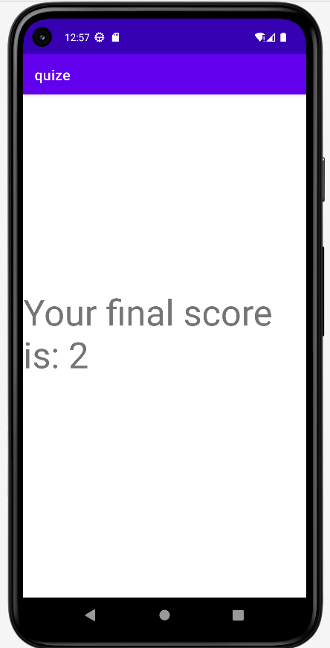

- Create an android application to implement Auto-complete Text View and Multi auto- Complete Text Views.

Design:

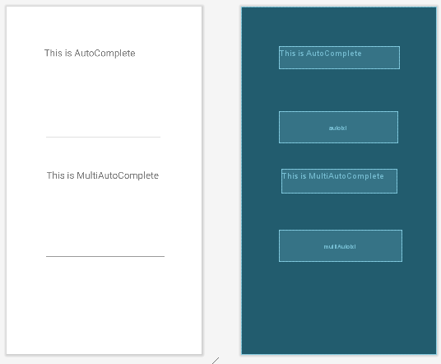

Xml Code:
<?xml version="1.0"encoding="utf-8"?>
<androidx.constraintlayout.widget.ConstraintLayout xmlns:android="http://schemas.android.com/apk/res/android"
xmlns:app="http://schemas.android.com/apk/res-auto"
xmlns:tools="http://schemas.android.com/tools"
android:layout_width="match_parent"
android:layout_height="match_parent"
tools:context=".MainActivity">
<TextView
android:id="@+id/textView"
android:layout_width="253dp"
android:layout_height="47dp"
android:text="This is AutoComplete "
android:textSize="20dp"
app:layout_constraintBottom_toBottomOf="parent"
app:layout_constraintEnd_toEndOf="parent"
app:layout_constraintStart_toStartOf="parent"
app:layout_constraintTop_toTopOf="parent"
app:layout_constraintVertical_bias="0.122"/>
<AutoCompleteTextView
android:id="@+id/autotxt"
android:layout_width="250dp"
android:layout_height="65dp"
app:layout_constraintBottom_toBottomOf="parent"
app:layout_constraintEnd_toEndOf="parent"
app:layout_constraintHorizontal_bias="0.49"
app:layout_constraintStart_toStartOf="parent"
app:layout_constraintTop_toTopOf="parent"
app:layout_constraintVertical_bias="0.328"/>
<TextView
android:id="@+id/textView2"
android:layout_width="243dp"
android:layout_height="50dp"
android:text="This is MultiAutoComplete"
android:textSize="20dp"
app:layout_constraintBottom_toBottomOf="parent"
app:layout_constraintEnd_toEndOf="parent"
app:layout_constraintStart_toStartOf="parent"
app:layout_constraintTop_toTopOf="parent"/>
<MultiAutoCompleteTextView
android:id="@+id/multiAutotxt"
android:layout_width="258dp"
android:layout_height="65dp"
app:layout_constraintBottom_toBottomOf="parent"
app:layout_constraintEnd_toEndOf="parent"
app:layout_constraintHorizontal_bias="0.516"
app:layout_constraintStart_toStartOf="parent"
app:layout_constraintTop_toTopOf="parent"
app:layout_constraintVertical_bias="0.704"/>
</androidx.constraintlayout.widget.ConstraintLayout>

Code:
MainActivity.java

package com.example.autocomplete;
import androidx.appcompat.app.AppCompatActivity;
import android.os.Bundle;
import android.widget.ArrayAdapter;
import android.widget.AutoCompleteTextView;
import android.widget.ListAdapter;
import android.widget.MultiAutoCompleteTextView;
public class MainActivity extends AppCompatActivity {
String[] countries={"India","Australia","West indies","indonesia","Indiana",
"South Africa","England","Bangladesh","Srilanka","singapore"};
@Override
protected void onCreate(Bundle savedInstanceState) {
super.onCreate(savedInstanceState);
setContentView(R.layout.activity_main);
ArrayAdapter<String>adapter=new ArrayAdapter<String>(this,android.R.layout.simple_dropdown_item_1line,countries);
AutoCompleteTextView textView=(AutoCompleteTextView)findViewById(R.id.autotxt);
textView.setThreshold(1);
textView.setAdapter(adapter);
MultiAutoCompleteTextView multitextView=(MultiAutoCompleteTextView)findViewById(R.id.multiAutotxt);
ArrayAdapter<String>aadapter=new ArrayAdapter<String>(this,android.R.layout.simple_dropdown_item_1line,countries);
multitextView.setThreshold(1);
multitextView.setTokenizer(new MultiAutoCompleteTextView.CommaTokenizer());
multitextView.setAdapter(aadapter);
}
}

Output:

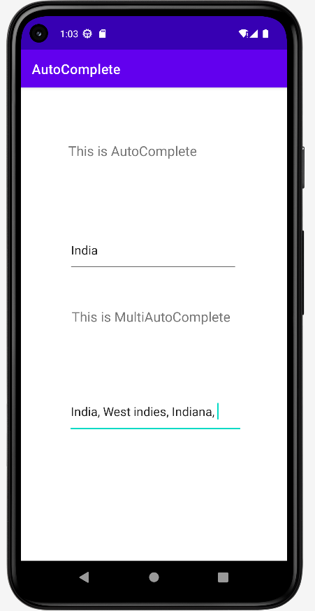

- Create an android application to implement Calculator program.

Design:

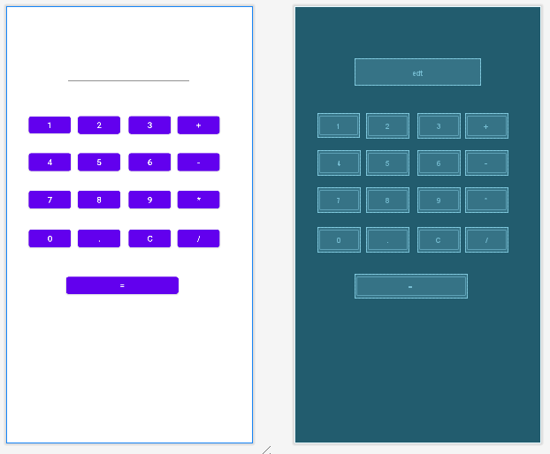

Xml Code:
<?xml version="1.0" encoding="utf-8"?>
<androidx.constraintlayout.widget.ConstraintLayout xmlns:android="http://schemas.android.com/apk/res/android"
xmlns:app="http://schemas.android.com/apk/res-auto"
xmlns:tools="http://schemas.android.com/tools"
android:layout_width="match_parent"
android:layout_height="match_parent"
tools:context=".MainActivity">
<Button
android:id="@+id/equal"
android:layout_width="188dp"
android:layout_height="40dp"
android:text="="
app:layout_constraintBottom_toBottomOf="parent"
app:layout_constraintEnd_toEndOf="parent"
app:layout_constraintHorizontal_bias="0.448"
app:layout_constraintStart_toStartOf="parent"
app:layout_constraintTop_toTopOf="parent"
app:layout_constraintVertical_bias="0.648" />
<Button
android:id="@+id/zero"
android:layout_width="71dp"
android:layout_height="41dp"
android:text="0"
app:layout_constraintBottom_toBottomOf="parent"
app:layout_constraintEnd_toEndOf="parent"
app:layout_constraintHorizontal_bias="0.111"
app:layout_constraintStart_toStartOf="parent"
app:layout_constraintTop_toTopOf="parent"
app:layout_constraintVertical_bias="0.534" />
<Button
android:id="@+id/dot"
android:layout_width="71dp"
android:layout_height="41dp"
android:text="."
app:layout_constraintBottom_toBottomOf="parent"
app:layout_constraintEnd_toEndOf="parent"
app:layout_constraintHorizontal_bias="0.352"
app:layout_constraintStart_toStartOf="parent"
app:layout_constraintTop_toTopOf="parent"
app:layout_constraintVertical_bias="0.534" />
<Button
android:id="@+id/clear"
android:layout_width="71dp"
android:layout_height="41dp"
android:text="c"
app:layout_constraintBottom_toBottomOf="parent"
app:layout_constraintEnd_toEndOf="parent"
app:layout_constraintHorizontal_bias="0.602"
app:layout_constraintStart_toStartOf="parent"
app:layout_constraintTop_toTopOf="parent"
app:layout_constraintVertical_bias="0.534" />
<Button
android:id="@+id/divide"
android:layout_width="71dp"
android:layout_height="41dp"
android:text="/"
app:layout_constraintBottom_toBottomOf="parent"
app:layout_constraintEnd_toEndOf="parent"
app:layout_constraintHorizontal_bias="0.841"
app:layout_constraintStart_toStartOf="parent"
app:layout_constraintTop_toTopOf="parent"
app:layout_constraintVertical_bias="0.534" />
<Button
android:id="@+id/multiply"
android:layout_width="71dp"
android:layout_height="41dp"
android:text="*"
app:layout_constraintBottom_toBottomOf="parent"
app:layout_constraintEnd_toEndOf="parent"
app:layout_constraintHorizontal_bias="0.841"
app:layout_constraintStart_toStartOf="parent"
app:layout_constraintTop_toTopOf="parent"
app:layout_constraintVertical_bias="0.44" />
<Button
android:id="@+id/nine"
android:layout_width="71dp"
android:layout_height="41dp"
android:text="9"
app:layout_constraintBottom_toBottomOf="parent"
app:layout_constraintEnd_toEndOf="parent"
app:layout_constraintHorizontal_bias="0.602"
app:layout_constraintStart_toStartOf="parent"
app:layout_constraintTop_toTopOf="parent"
app:layout_constraintVertical_bias="0.44" />
<Button
android:id="@+id/eight"
android:layout_width="71dp"
android:layout_height="41dp"
android:text="8"
app:layout_constraintBottom_toBottomOf="parent"
app:layout_constraintEnd_toEndOf="parent"
app:layout_constraintHorizontal_bias="0.352"
app:layout_constraintStart_toStartOf="parent"
app:layout_constraintTop_toTopOf="parent"
app:layout_constraintVertical_bias="0.44" />
<Button
android:id="@+id/seven"
android:layout_width="71dp"
android:layout_height="41dp"
android:text="7"
app:layout_constraintBottom_toBottomOf="parent"
app:layout_constraintEnd_toEndOf="parent"
app:layout_constraintHorizontal_bias="0.111"
app:layout_constraintStart_toStartOf="parent"
app:layout_constraintTop_toTopOf="parent"
app:layout_constraintVertical_bias="0.44" />
<Button
android:id="@+id/minus"
android:layout_width="71dp"
android:layout_height="41dp"
android:text="-"
app:layout_constraintBottom_toBottomOf="parent"
app:layout_constraintEnd_toEndOf="parent"
app:layout_constraintHorizontal_bias="0.841"
app:layout_constraintStart_toStartOf="parent"
app:layout_constraintTop_toTopOf="parent"
app:layout_constraintVertical_bias="0.349" />
<Button
android:id="@+id/six"
android:layout_width="71dp"
android:layout_height="41dp"
android:text="6"
app:layout_constraintBottom_toBottomOf="parent"
app:layout_constraintEnd_toEndOf="parent"
app:layout_constraintHorizontal_bias="0.602"
app:layout_constraintStart_toStartOf="parent"
app:layout_constraintTop_toTopOf="parent"
app:layout_constraintVertical_bias="0.349" />
<Button
android:id="@+id/five"
android:layout_width="71dp"
android:layout_height="41dp"
android:text="5"
app:layout_constraintBottom_toBottomOf="parent"
app:layout_constraintEnd_toEndOf="parent"
app:layout_constraintHorizontal_bias="0.352"
app:layout_constraintStart_toStartOf="parent"
app:layout_constraintTop_toTopOf="parent"
app:layout_constraintVertical_bias="0.349" />
<Button
android:id="@+id/plus"
android:layout_width="71dp"
android:layout_height="41dp"
android:text="+"
app:layout_constraintBottom_toBottomOf="parent"
app:layout_constraintEnd_toEndOf="parent"
app:layout_constraintHorizontal_bias="0.841"
app:layout_constraintStart_toStartOf="parent"
app:layout_constraintTop_toTopOf="parent"
app:layout_constraintVertical_bias="0.259" />
<Button
android:id="@+id/three"
android:layout_width="71dp"
android:layout_height="41dp"
android:text="3"
app:layout_constraintBottom_toBottomOf="parent"
app:layout_constraintEnd_toEndOf="parent"
app:layout_constraintHorizontal_bias="0.602"
app:layout_constraintStart_toStartOf="parent"
app:layout_constraintTop_toTopOf="parent"
app:layout_constraintVertical_bias="0.259" />
<EditText
android:id="@+id/edt"
android:layout_width="wrap_content"
android:layout_height="wrap_content"
android:ems="10"
android:inputType="textPersonName"
app:layout_constraintBottom_toBottomOf="parent"
app:layout_constraintEnd_toEndOf="parent"
app:layout_constraintHorizontal_bias="0.497"
app:layout_constraintStart_toStartOf="parent"
app:layout_constraintTop_toTopOf="parent"
app:layout_constraintVertical_bias="0.128" />
<Button
android:id="@+id/one"
android:layout_width="70dp"
android:layout_height="40dp"
android:text="1"
app:layout_constraintBottom_toBottomOf="parent"
app:layout_constraintEnd_toEndOf="parent"
app:layout_constraintHorizontal_bias="0.111"
app:layout_constraintStart_toStartOf="parent"
app:layout_constraintTop_toTopOf="parent"
app:layout_constraintVertical_bias="0.259" />
<Button
android:id="@+id/four"
android:layout_width="71dp"
android:layout_height="41dp"
android:text="4"
app:layout_constraintBottom_toBottomOf="parent"
app:layout_constraintEnd_toEndOf="parent"
app:layout_constraintHorizontal_bias="0.111"
app:layout_constraintStart_toStartOf="parent"
app:layout_constraintTop_toTopOf="parent"
app:layout_constraintVertical_bias="0.349" />
<Button
android:id="@+id/two"
android:layout_width="71dp"
android:layout_height="41dp"
android:text="2"
app:layout_constraintBottom_toBottomOf="parent"
app:layout_constraintEnd_toEndOf="parent"
app:layout_constraintHorizontal_bias="0.352"
app:layout_constraintStart_toStartOf="parent"
app:layout_constraintTop_toTopOf="parent"
app:layout_constraintVertical_bias="0.259" />
</androidx.constraintlayout.widget.ConstraintLayout>

MainActivity.java:
package com.example.calc;
import androidx.appcompat.app.AppCompatActivity;
import android.os.Bundle;
import android.view.View;
import android.widget.Button;
import android.widget.EditText;
public class MainActivity extends AppCompatActivity {
float mvalueone,mvaluetwo;
boolean resultadd,resultsub,resultmulti,resultdev;
@Override
protected void onCreate(Bundle savedInstanceState) {
super.onCreate(savedInstanceState);
setContentView(R.layout.activity_main);
Button one=(Button) findViewById(R.id.one);
Button two=(Button) findViewById(R.id.two);
Button three=(Button) findViewById(R.id.three);
Button plus=(Button) findViewById(R.id.plus);
Button four=(Button) findViewById(R.id.four);
Button five=(Button) findViewById(R.id.five);
Button six=(Button) findViewById(R.id.six);
Button minus=(Button) findViewById(R.id.minus);
Button seven=(Button) findViewById(R.id.seven);
Button eight=(Button) findViewById(R.id.eight);
Button nine=(Button) findViewById(R.id.nine);
Button multi=(Button) findViewById(R.id.multiply);
Button zero=(Button) findViewById(R.id.zero);
Button dot=(Button) findViewById(R.id.dot);
Button clear=(Button) findViewById(R.id.clear);
Button divide=(Button) findViewById(R.id.divide);
Button equal=(Button) findViewById(R.id.equal);
EditText result=(EditText) findViewById(R.id.edt);
one.setOnClickListener(new View.OnClickListener() {
@Override
public void onClick(View view) {
result.setText(result.getText()+"1");
}
});
two.setOnClickListener(new View.OnClickListener() {
@Override
public void onClick(View view) {
result.setText(result.getText()+"2");
}
});
three.setOnClickListener(new View.OnClickListener() {
@Override
public void onClick(View view) {
result.setText(result.getText()+"3");
}
});
four.setOnClickListener(new View.OnClickListener() {
@Override
public void onClick(View view) {
result.setText(result.getText()+"4");
}
});
five.setOnClickListener(new View.OnClickListener() {
@Override
public void onClick(View view) {
result.setText(result.getText()+"5");
}
});
six.setOnClickListener(new View.OnClickListener() {
@Override
public void onClick(View view) {
result.setText(result.getText()+"6");
}
});
seven.setOnClickListener(new View.OnClickListener() {
@Override
public void onClick(View view) {
result.setText(result.getText()+"7");
}
});
eight.setOnClickListener(new View.OnClickListener() {
@Override
public void onClick(View view) {
result.setText(result.getText()+"8");
}
});
nine.setOnClickListener(new View.OnClickListener() {
@Override
public void onClick(View view) {
result.setText(result.getText()+"9");
}
});
dot.setOnClickListener(new View.OnClickListener() {
@Override
public void onClick(View view) {
result.setText(result.getText()+".");
}
});
zero.setOnClickListener(new View.OnClickListener() {
@Override
public void onClick(View view) {
result.setText(result.getText()+"0");
}
});
plus.setOnClickListener(new View.OnClickListener() {
@Override
public void onClick(View view) {
if(result==null){
result.setText("");
}else{
mvalueone=Float.parseFloat(result.getText()+"");
resultadd=true;
result.setText(null);
}
}
});
minus.setOnClickListener(new View.OnClickListener() {
@Override
public void onClick(View view) {
if(result==null){
result.setText("");
}else{
mvalueone=Float.parseFloat(result.getText()+"");
resultsub=true;
result.setText(null);
}
}
});
multi.setOnClickListener(new View.OnClickListener() {
@Override
public void onClick(View view) {
if(result==null){
result.setText("");
}else{
mvalueone=Float.parseFloat(result.getText()+"");
resultmulti=true;
result.setText(null);
}
}
});
divide.setOnClickListener(new View.OnClickListener() {
@Override
public void onClick(View view) {
if(result==null){
result.setText("");
}else{
mvalueone=Float.parseFloat(result.getText()+"");
resultdev=true;
result.setText(null);
}
}
});
equal.setOnClickListener(new View.OnClickListener() {
@Override
public void onClick(View view) {
mvaluetwo=Float.parseFloat(result.getText()+"");
if (resultadd==true)
{
result.setText(mvalueone+mvaluetwo+"");
resultadd=false;
}
if (resultsub==true)
{
result.setText(mvalueone-mvaluetwo+"");
resultsub=false;
}
if (resultmulti==true)
{
result.setText(mvalueone*mvaluetwo+"");
resultmulti=false;
}
if (resultdev==true)
{
result.setText(mvalueone/mvaluetwo+"");
resultdev=false;
}
}
});
clear.setOnClickListener(new View.OnClickListener() {
@Override
public void onClick(View view) {
result.setText("");
}
});
}
}

Output:

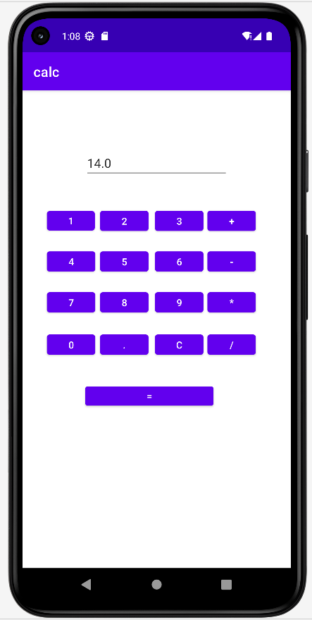

- Create an android application to build a resume by using Resume Builder App(Profile).

Design:

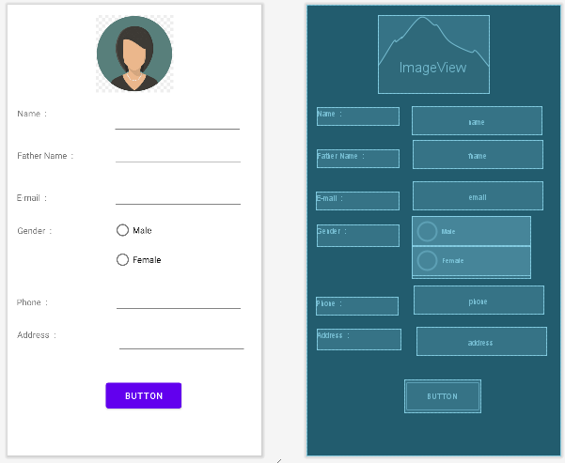

Xml Code:
<?xml version="1.0"encoding="utf-8"?>
<androidx.constraintlayout.widget.ConstraintLayout xmlns:android="http://schemas.android.com/apk/res/android"
xmlns:app="http://schemas.android.com/apk/res-auto"
xmlns:tools="http://schemas.android.com/tools"
android:layout_width="match_parent"
android:layout_height="match_parent"
tools:context=".MainActivity">
<ImageView
android:id="@+id/imageView"
android:layout_width="179dp"
android:layout_height="126dp"
android:layout_marginStart="116dp"
android:layout_marginTop="16dp"
android:layout_marginEnd="116dp"
android:layout_marginBottom="589dp"
app:layout_constraintBottom_toBottomOf="parent"
app:layout_constraintEnd_toEndOf="parent"
app:layout_constraintStart_toStartOf="parent"
app:layout_constraintTop_toTopOf="parent"
app:srcCompat="@drawable/profile"/>
<TextView
android:id="@+id/textView"
android:layout_width="133dp"
android:layout_height="29dp"
android:text="Father Name :"
app:layout_constraintBottom_toBottomOf="parent"
app:layout_constraintEnd_toEndOf="parent"
app:layout_constraintHorizontal_bias="0.057"
app:layout_constraintStart_toStartOf="parent"
app:layout_constraintTop_toTopOf="parent"
app:layout_constraintVertical_bias="0.334"
tools:ignore="DuplicateIds"/>
<EditText
android:id="@+id/name"
android:layout_width="wrap_content"
android:layout_height="wrap_content"
android:ems="10"
android:inputType="textPersonName"
app:layout_constraintBottom_toBottomOf="parent"
app:layout_constraintEnd_toEndOf="parent"
app:layout_constraintHorizontal_bias="0.845"
app:layout_constraintStart_toStartOf="parent"
app:layout_constraintTop_toTopOf="parent"
app:layout_constraintVertical_bias="0.241"/>
<TextView
android:id="@+id/textView1"
android:layout_width="133dp"
android:layout_height="29dp"
android:text="Name :"
app:layout_constraintBottom_toBottomOf="parent"
app:layout_constraintEnd_toEndOf="parent"
app:layout_constraintHorizontal_bias="0.057"
app:layout_constraintStart_toStartOf="parent"
app:layout_constraintTop_toTopOf="parent"
app:layout_constraintVertical_bias="0.237"/>
<EditText
android:id="@+id/fname"
android:layout_width="wrap_content"
android:layout_height="wrap_content"
android:ems="10"
android:inputType="textPersonName"
app:layout_constraintBottom_toBottomOf="parent"
app:layout_constraintEnd_toEndOf="parent"
app:layout_constraintHorizontal_bias="0.85"
app:layout_constraintStart_toStartOf="parent"
app:layout_constraintTop_toTopOf="parent"
app:layout_constraintVertical_bias="0.319"
tools:ignore="DuplicateIds"/>
<TextView
android:id="@+id/textView4"
android:layout_width="133dp"
android:layout_height="35dp"
android:text="Gender :"
app:layout_constraintBottom_toBottomOf="parent"
app:layout_constraintEnd_toEndOf="parent"
app:layout_constraintHorizontal_bias="0.057"
app:layout_constraintStart_toStartOf="parent"
app:layout_constraintTop_toTopOf="parent"
app:layout_constraintVertical_bias="0.512"/>
<RadioGroup
android:id="@id/radiogroup"
android:layout_width="192dp"
android:layout_height="101dp"
app:layout_constraintBottom_toBottomOf="parent"
app:layout_constraintEnd_toEndOf="parent"
app:layout_constraintHorizontal_bias="0.778"
app:layout_constraintStart_toStartOf="parent"
app:layout_constraintTop_toTopOf="parent"
app:layout_constraintVertical_bias="0.542">
<RadioButton
android:id="@+id/rb1"
android:layout_width="match_parent"
android:layout_height="wrap_content"
android:text="Male"/>
<RadioButton
android:id="@+id/rb2"
android:layout_width="match_parent"
android:layout_height="wrap_content"
android:text="Female"/>
</RadioGroup>
<TextView
android:id="@+id/textView2"
android:layout_width="133dp"
android:layout_height="28dp"
android:text="Phone :"
app:layout_constraintBottom_toBottomOf="parent"
app:layout_constraintEnd_toEndOf="parent"
app:layout_constraintHorizontal_bias="0.053"
app:layout_constraintStart_toStartOf="parent"
app:layout_constraintTop_toTopOf="parent"
app:layout_constraintVertical_bias="0.672"/>
<EditText
android:id="@+id/phone"
android:layout_width="wrap_content"
android:layout_height="wrap_content"
android:ems="10"
android:inputType="phone"
app:layout_constraintBottom_toBottomOf="parent"
app:layout_constraintEnd_toEndOf="parent"
app:layout_constraintHorizontal_bias="0.855"
app:layout_constraintStart_toStartOf="parent"
app:layout_constraintTop_toTopOf="parent"
app:layout_constraintVertical_bias="0.664"/>
<TextView
android:id="@+id/textView3"
android:layout_width="134dp"
android:layout_height="29dp"
android:text="E-mail :"
app:layout_constraintBottom_toBottomOf="parent"
app:layout_constraintEnd_toEndOf="parent"
app:layout_constraintHorizontal_bias="0.054"
app:layout_constraintStart_toStartOf="parent"
app:layout_constraintTop_toTopOf="parent"
app:layout_constraintVertical_bias="0.431"/>
<EditText
android:id="@+id/email"
android:layout_width="wrap_content"
android:layout_height="wrap_content"
android:ems="10"
android:inputType="textEmailAddress"
app:layout_constraintBottom_toBottomOf="parent"
app:layout_constraintEnd_toEndOf="parent"
app:layout_constraintHorizontal_bias="0.85"
app:layout_constraintStart_toStartOf="parent"
app:layout_constraintTop_toTopOf="parent"
app:layout_constraintVertical_bias="0.418"/>
<TextView
android:id="@+id/textView5"
android:layout_width="136dp"
android:layout_height="34dp"
android:text="Address :"
app:layout_constraintBottom_toBottomOf="parent"
app:layout_constraintEnd_toEndOf="parent"
app:layout_constraintHorizontal_bias="0.057"
app:layout_constraintStart_toStartOf="parent"
app:layout_constraintTop_toTopOf="parent"
app:layout_constraintVertical_bias="0.753"/>
<EditText
android:id="@+id/address"
android:layout_width="wrap_content"
android:layout_height="wrap_content"
android:layout_marginStart="25dp"
android:layout_marginTop="20dp"
android:layout_marginEnd="24dp"
android:layout_marginBottom="165dp"
android:ems="10"
android:inputType="textPersonName"
app:layout_constraintBottom_toBottomOf="parent"
app:layout_constraintEnd_toEndOf="parent"
app:layout_constraintStart_toEndOf="@+id/textView5"
app:layout_constraintTop_toBottomOf="@+id/phone"/>
<Button
android:id="@+id/button"
android:layout_width="123dp"
android:layout_height="53dp"
android:layout_marginStart="159dp"
android:layout_marginTop="41dp"
android:layout_marginEnd="129dp"
android:layout_marginBottom="71dp"
android:text="Button"
app:layout_constraintBottom_toBottomOf="parent"
app:layout_constraintEnd_toEndOf="parent"
app:layout_constraintStart_toStartOf="parent"
app:layout_constraintTop_toBottomOf="@+id/address"/>
</androidx.constraintlayout.widget.ConstraintLayout>

MainActivity.java
package com.example.resume;
import androidx.appcompat.app.AppCompatActivity;
import android.content.Intent;
import android.os.Bundle;
import android.view.View;
import android.widget.Button;
import android.widget.EditText;
import android.widget.ImageView;
import android.widget.RadioButton;
import android.widget.Toast;
public class MainActivity extends AppCompatActivity {
Button button;
Intent intent;
String gender="female";
EditText nameedittext, fathernameedittext, addressedittext, contactedittext, emailedittext;
ImageView profileimage;
RadioButton malebutton;
Boolean isfilled;
@Override
protected void onCreate(Bundle savedInstanceState) {
super.onCreate(savedInstanceState);
setContentView(R.layout.activity_main);
button = (Button) findViewById(R.id.button);
nameedittext = (EditText) findViewById(R.id.name);
malebutton = (RadioButton) findViewById(R.id.rb1);
addressedittext = (EditText) findViewById(R.id.address);
fathernameedittext = (EditText) findViewById(R.id.fname);
contactedittext = (EditText) findViewById(R.id.phone);
emailedittext = (EditText) findViewById(R.id.email);
profileimage = (ImageView) findViewById(R.id.imageView);
button.setOnClickListener(new View.OnClickListener() {
@Override
public void onClick(View v) {
intent = new Intent(MainActivity.this, MainActivity2.class);
startActivity(intent);
isfilled = CheckAllFields();
if (malebutton.isChecked() == false) {
Toast.makeText(MainActivity.this, "Select Gender", Toast.LENGTH_SHORT).show();
} else if (malebutton.isChecked() == true) {
gender = "male";
} else {
gender = "female";
}
if (isfilled) {
intent = new Intent(MainActivity.this, MainActivity2.class);
intent.putExtra("name", nameedittext.getText().toString());
intent.putExtra("fname", fathernameedittext.getText().toString());
intent.putExtra("profile", R.drawable.profile);
intent.putExtra("gender", gender);
intent.putExtra("email", emailedittext.getText().toString());
intent.putExtra("contact", contactedittext.getText().toString());
intent.putExtra("address", addressedittext.getText().toString());
startActivity(intent);
}
}
});
}
private boolean CheckAllFields() {
if (nameedittext.length() == 0) {
nameedittext.setError("please enter name");
return false;
}
if (fathernameedittext.length() == 0) {
fathernameedittext.setError("please enter fathername");
return false;
}
if (emailedittext.length() == 0) {
emailedittext.setError("Please enter email");
return false;
}
if (contactedittext.length() == 0) {
contactedittext.setError("please enter contact");
return false;
}
if (addressedittext.length() == 0) {
addressedittext.setError("please enter address");
return false;
}
return true;
}
}

Output:

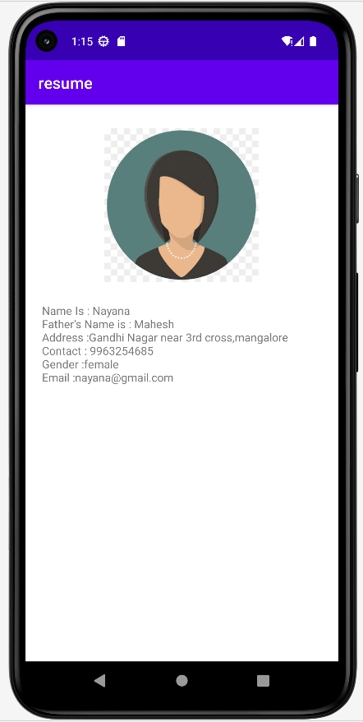
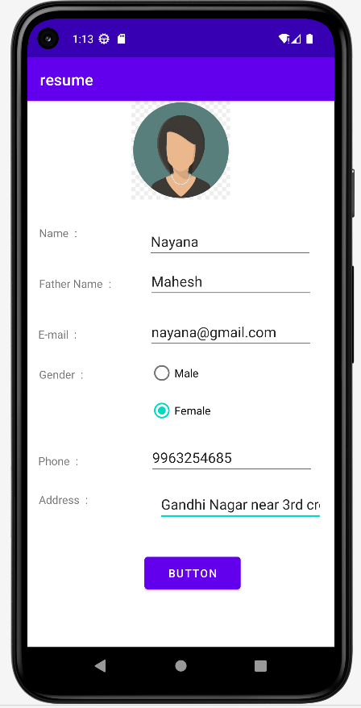

- Create an android application to implement music player app.

Design:

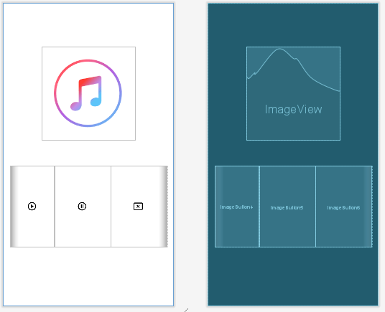

Xml code:
<?xml version="1.0" encoding="utf-8"?>
<androidx.constraintlayout.widget.ConstraintLayout xmlns:android="http://schemas.android.com/apk/res/android"
xmlns:app="http://schemas.android.com/apk/res-auto"
xmlns:tools="http://schemas.android.com/tools"
android:layout_width="match_parent"
android:layout_height="match_parent"
tools:context=".MainActivity">
<LinearLayout
android:id="@+id/linearLayout"
android:layout_width="378dp"
android:layout_height="196dp"
android:orientation="horizontal"
app:layout_constraintBottom_toBottomOf="parent"
app:layout_constraintEnd_toEndOf="parent"
app:layout_constraintStart_toStartOf="parent"
app:layout_constraintTop_toTopOf="parent"
app:layout_constraintVertical_bias="0.735">
<ImageButton
android:id="@+id/imageButton4"
style="@style/Widget.AppCompat.Button.Borderless.Colored"
android:layout_width="59dp"
android:layout_height="match_parent"
android:layout_weight="1"
android:onClick="play"
app:srcCompat="@drawable/pla" />
<ImageButton
android:id="@+id/imageButton5"
style="@style/Widget.AppCompat.Button.Borderless.Colored"
android:layout_width="wrap_content"
android:layout_height="match_parent"
android:layout_weight="1"
android:onClick="pause"
app:srcCompat="@drawable/paus" />
<ImageButton
android:id="@+id/imageButton6"
style="@style/Widget.AppCompat.Button.Borderless.Colored"
android:layout_width="wrap_content"
android:layout_height="match_parent"
android:layout_weight="1"
android:onClick="cancel"
app:srcCompat="@drawable/cance" />
</LinearLayout>
<ImageView
android:id="@+id/imageView"
android:layout_width="wrap_content"
android:layout_height="wrap_content"
app:layout_constraintBottom_toBottomOf="parent"
app:layout_constraintEnd_toEndOf="parent"
app:layout_constraintStart_toStartOf="parent"
app:layout_constraintTop_toTopOf="parent"
app:layout_constraintVertical_bias="0.209"
app:srcCompat="@drawable/music" />
</androidx.constraintlayout.widget.ConstraintLayout>

MainActivity.java

package com.example.music;
import androidx.appcompat.app.AppCompatActivity;
import android.animation.Animator;
import android.media.MediaPlayer;
import android.os.Bundle;
import android.view.View;
public class MainActivity extends AppCompatActivity {
MediaPlayer music;
@Override
protected void onCreate(Bundle savedInstanceState) {
super.onCreate(savedInstanceState);
setContentView(R.layout.activity_main);
music = MediaPlayer.create(this, R.raw.heeriye);
}
// Playing the music
public void play(View v)
{
music.start();
}
// Pausing the music
public void pause(View v)
{
music.pause();
}
// Stopping the music
public void cancel(View v)
{
music.stop();
music = MediaPlayer.create(this, R.raw.heeriye);
}
}

Output:

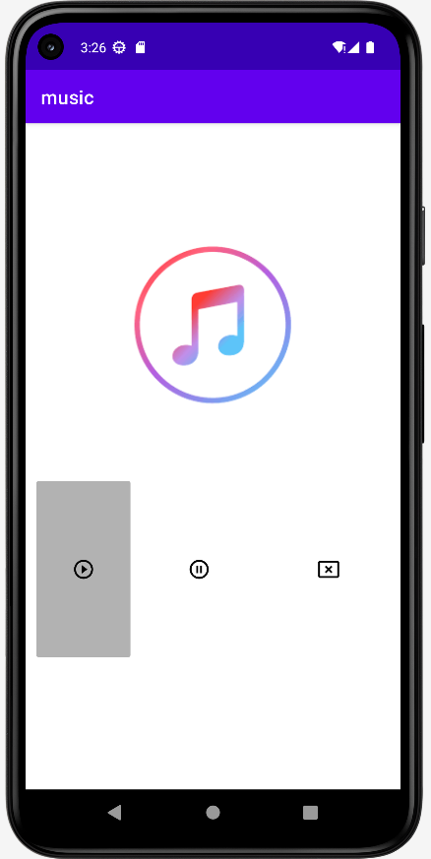

- Create an android application to implement currency converter app (Convert the currency from USD to INR).

Design:

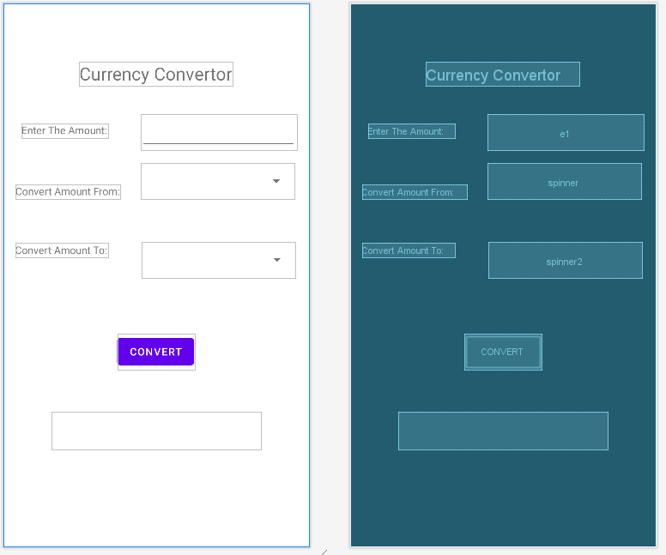
Xml Code:
<?xml version="1.0" encoding="utf-8"?>
<androidx.constraintlayout.widget.ConstraintLayout xmlns:android="http://schemas.android.com/apk/res/android"
xmlns:app="http://schemas.android.com/apk/res-auto"
xmlns:tools="http://schemas.android.com/tools"
android:layout_width="match_parent"
android:layout_height="match_parent"
tools:context=".MainActivity">
<TextView
android:id="@+id/textView"
android:layout_width="wrap_content"
android:layout_height="wrap_content"
android:layout_marginBottom="584dp"
android:text="Currency Convertor"
android:textSize="24sp"
app:layout_constraintBottom_toBottomOf="parent"
app:layout_constraintEnd_toEndOf="parent"
app:layout_constraintHorizontal_bias="0.497"
app:layout_constraintStart_toStartOf="parent"
app:layout_constraintTop_toTopOf="parent"
app:layout_constraintVertical_bias="0.678" />
<TextView
android:id="@+id/textView2"
android:layout_width="wrap_content"
android:layout_height="wrap_content"
android:layout_marginBottom="518dp"
android:text="Enter The Amount:"
app:layout_constraintBottom_toBottomOf="parent"
app:layout_constraintEnd_toEndOf="parent"
app:layout_constraintHorizontal_bias="0.081"
app:layout_constraintStart_toStartOf="parent"
app:layout_constraintTop_toTopOf="parent"
app:layout_constraintVertical_bias="0.829" />
<TextView
android:id="@+id/textView4"
android:layout_width="wrap_content"
android:layout_height="wrap_content"
android:layout_marginTop="63dp"
android:text="Convert Amount From:"
app:layout_constraintBottom_toBottomOf="parent"
app:layout_constraintEnd_toEndOf="parent"
app:layout_constraintHorizontal_bias="0.059"
app:layout_constraintStart_toStartOf="parent"
app:layout_constraintTop_toBottomOf="@+id/textView2"
app:layout_constraintVertical_bias="0.0" />
<Spinner
android:id="@+id/spinner"
android:layout_width="206dp"
android:layout_height="48dp"
android:layout_marginBottom="468dp"
app:layout_constraintBottom_toBottomOf="parent"
app:layout_constraintEnd_toEndOf="parent"
app:layout_constraintHorizontal_bias="0.583"
app:layout_constraintStart_toEndOf="@+id/textView4" />
<TextView
android:id="@+id/textView5"
android:layout_width="wrap_content"
android:layout_height="wrap_content"
android:layout_marginTop="52dp"
android:text="Convert Amount To:"
app:layout_constraintBottom_toBottomOf="parent"
app:layout_constraintEnd_toEndOf="parent"
app:layout_constraintHorizontal_bias="0.055"
app:layout_constraintStart_toStartOf="parent"
app:layout_constraintTop_toBottomOf="@+id/spinner"
app:layout_constraintVertical_bias="0.017" />
<Spinner
android:id="@+id/spinner2"
android:layout_width="206dp"
android:layout_height="48dp"
android:layout_marginTop="58dp"
app:layout_constraintBottom_toBottomOf="parent"
app:layout_constraintEnd_toEndOf="parent"
app:layout_constraintHorizontal_bias="0.707"
app:layout_constraintStart_toEndOf="@+id/textView5"
app:layout_constraintTop_toBottomOf="@+id/spinner"
app:layout_constraintVertical_bias="0.0" />
<Button
android:id="@+id/button"
android:layout_width="wrap_content"
android:layout_height="wrap_content"
android:layout_marginTop="62dp"
android:text="CONVERT"
app:layout_constraintBottom_toBottomOf="parent"
app:layout_constraintEnd_toEndOf="parent"
app:layout_constraintHorizontal_bias="0.498"
app:layout_constraintStart_toStartOf="parent"
app:layout_constraintTop_toBottomOf="@+id/spinner2"
app:layout_constraintVertical_bias="0.055" />
<TextView
android:id="@+id/textView6"
android:layout_width="282dp"
android:layout_height="51dp"
android:layout_marginTop="56dp"
app:layout_constraintBottom_toBottomOf="parent"
app:layout_constraintEnd_toEndOf="parent"
app:layout_constraintStart_toStartOf="parent"
app:layout_constraintTop_toBottomOf="@+id/button"
app:layout_constraintVertical_bias="0.0" />
<EditText
android:id="@+id/e1"
android:layout_width="wrap_content"
android:layout_height="wrap_content"
android:layout_marginTop="39dp"
android:ems="10"
android:inputType="numberDecimal"
android:minHeight="48dp"
app:layout_constraintBottom_toTopOf="@+id/spinner"
app:layout_constraintEnd_toEndOf="parent"
app:layout_constraintHorizontal_bias="0.724"
app:layout_constraintStart_toEndOf="@+id/textView2"
app:layout_constraintTop_toBottomOf="@+id/textView"
app:layout_constraintVertical_bias="0.0" />
</androidx.constraintlayout.widget.ConstraintLayout>

MainActivity.java:

package com.example.currency;
import androidx.appcompat.app.AppCompatActivity;
import android.os.Bundle;
import android.view.View;
import android.widget.ArrayAdapter;
import android.widget.Button;
import android.widget.EditText;
import android.widget.Spinner;
import android.widget.TextView;
public class MainActivity extends AppCompatActivity {
@Override
protected void onCreate(Bundle savedInstanceState) {
super.onCreate(savedInstanceState);
setContentView(R.layout.activity_main);
Button b=(Button) findViewById(R.id.button);
Spinner sp1=(Spinner) findViewById(R.id.spinner);
Spinner sp2=(Spinner) findViewById(R.id.spinner2);
EditText e1=(EditText) findViewById(R.id.e1);
TextView t=(TextView)findViewById(R.id.textView6);
String[] curr = {"Select the currency","USD","IndianRupees","Euro"};
ArrayAdapter ad = new ArrayAdapter<String>(MainActivity.this,android. R.layout.simple_spinner_dropdown_item, curr);
sp1.setAdapter(ad);
//String[] to = {"USD","IndianRupees","Euro"};
ArrayAdapter ad2= new ArrayAdapter<String>(MainActivity.this,android. R.layout.simple_spinner_dropdown_item, curr);
sp2.setAdapter(ad2);
b.setOnClickListener(new View.OnClickListener() {
@Override
public void onClick(View view) {
Double tot;
Double amt = Double.parseDouble(e1.getText().toString());
if(sp1.getSelectedItem().toString()=="USD" && sp2.getSelectedItem().toString() == "IndianRupees")
{
tot = amt * 79.89;
t.setText("The Converted Amount is:"+tot);
}
else if(sp1.getSelectedItem().toString() == "USD" &&sp2.getSelectedItem().toString() == "Euro")
{
tot = amt*1.01;
t.setText("The Converted Amount is:"+tot);
}
else if(sp1.getSelectedItem().toString() == "IndianRupees" &&sp2.getSelectedItem().toString() == "USD")
{
tot = amt/79.89;
t.setText("The Converted Amount is:"+tot);
}
else if(sp1.getSelectedItem().toString() == "IndianRupees" &&sp2.getSelectedItem().toString() == "Euro")
{
tot = amt/79.23;
t.setText("The Converted Amount is:"+tot);
}
else if(sp1.getSelectedItem().toString() == "Euro" &&sp2.getSelectedItem().toString() == "USD")
{
tot = amt*0.99;
t.setText("The Converted Amount is:"+tot);
}
else if(sp1.getSelectedItem().toString() == "Euro" &&sp2.getSelectedItem().toString() == "IndianRupees")
{
tot = amt*79.22;
t.setText("The Converted Amount is:"+tot);
}
}
});
}
}

Output:

